This is my final report of my gaming website, to which I discuss each of my webpage in detail and providing screenshots for all.
CST2120 Web Application and Database
Project Report
Abdullahi Mohamed
Project Report
Homepage
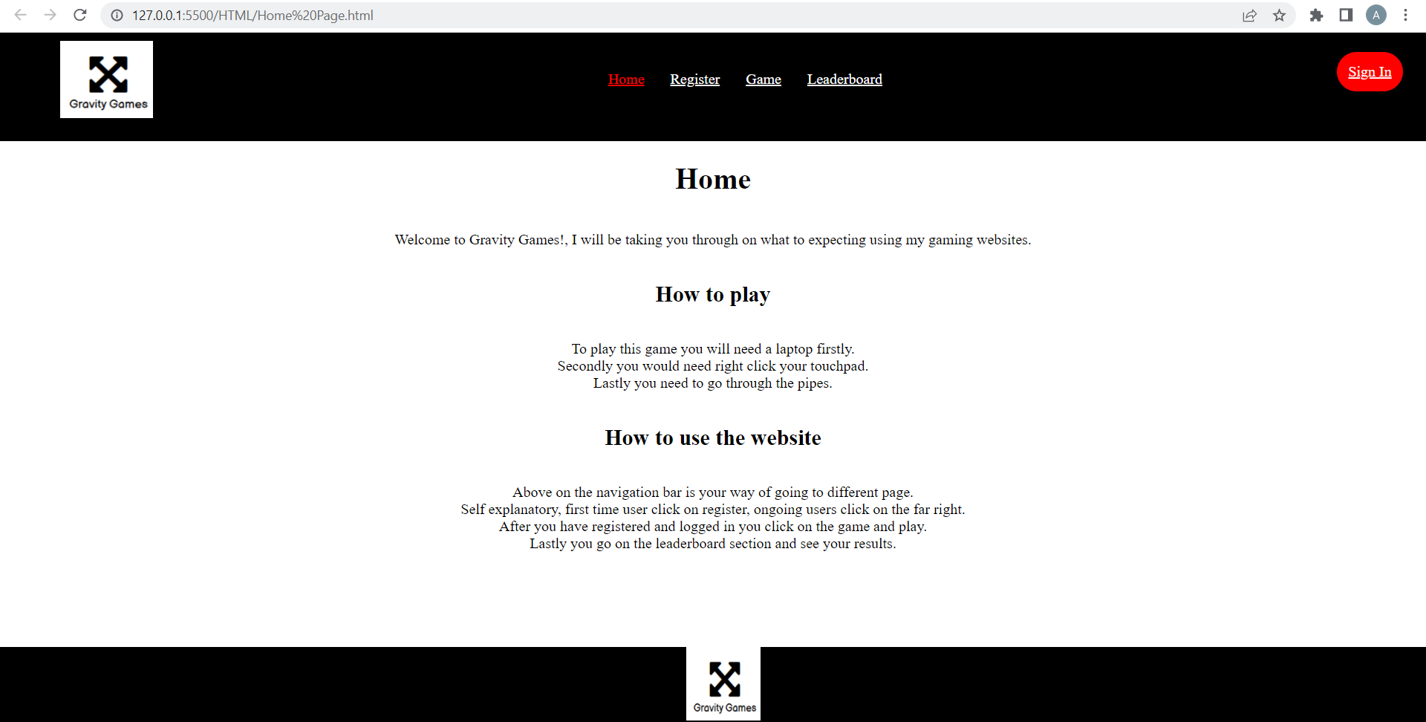

This is my home page in my gaming website to which I opted for a basic look; I have included necessary information for users to understand what to do on the website. I have got the same navigation bar and footer for all page’s bar the gaming webpage. I have gone for a black, white, and red theme because those are the colour way for my game. In all hyperlinks I have inserted a hover function so that the colour switch, this enables for the user to confirm they are on the correct website.
Registration
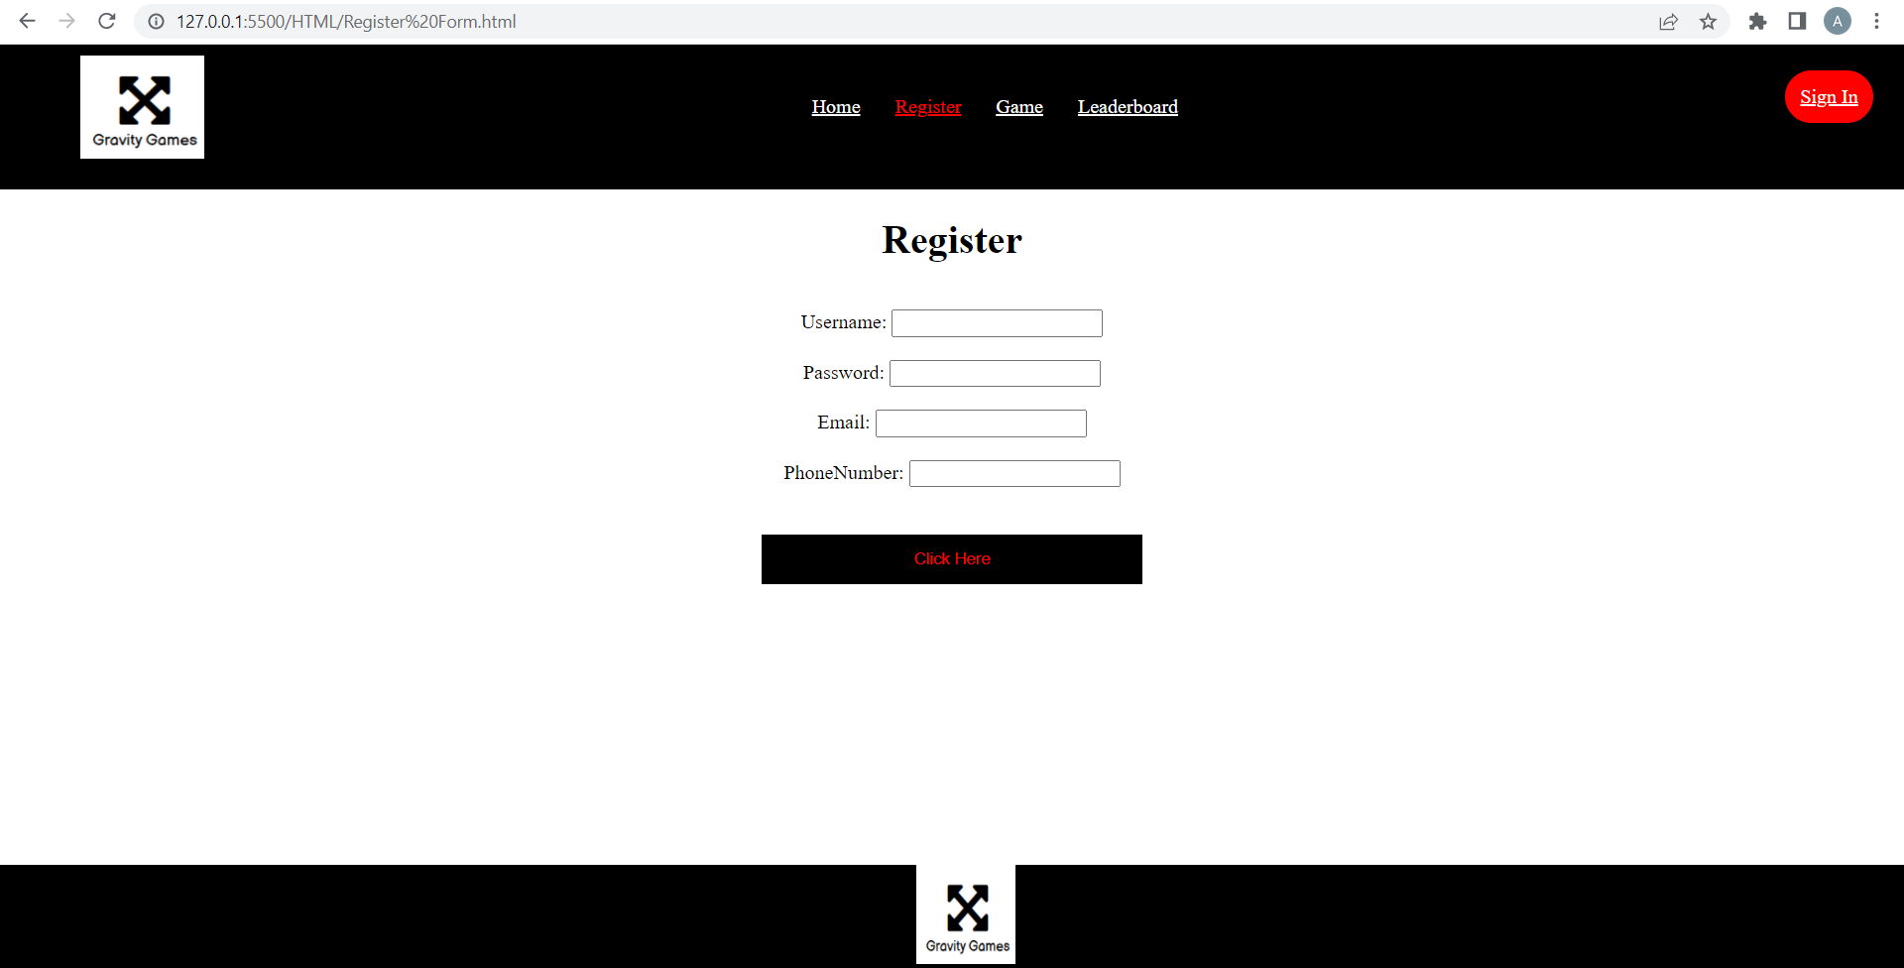
This is my registration page to which it all information from the user is stored in JSON, that helps remain all the correct details for when the user is decides to login. I have provided to store two additional data in JSON to which I decided to add the email data and phone number of the user. This helps create a difference between users with the same username and password.
Login
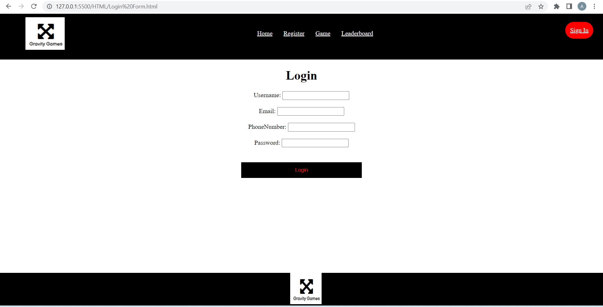
To login you need to press the “sign in” button on the far right, this where you have already registered. Therefore, you must provide the correct username and password to login, or the system will not allow you to progress, this functionality allows my gaming website to be safe and secure because it ensure credibility.


This is what you receive when you log in with the correct details whilst incorrect details receive an error message.

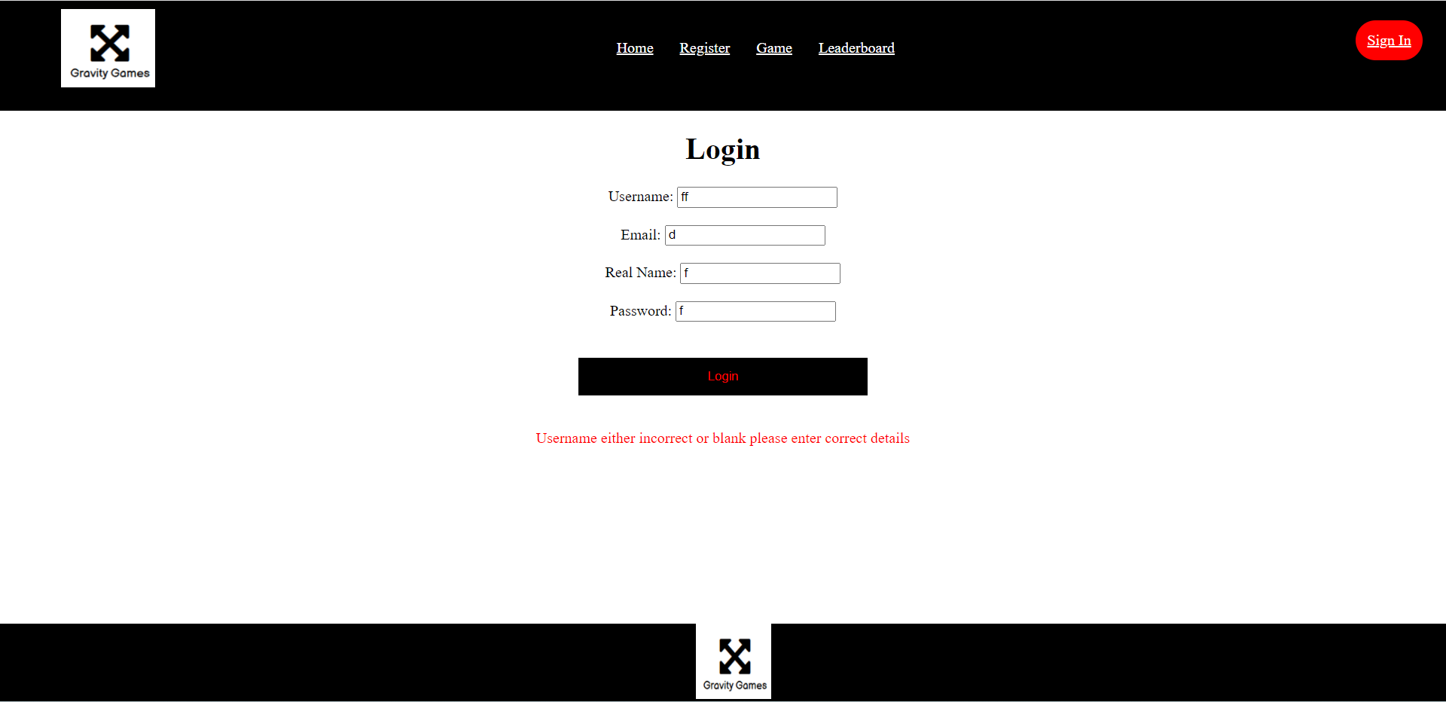
You receive an error handling message if you don’t include correct registering details, therefore you must ensure that you have entered the correct details, or you cannot proceed to the next page.
Gaming Page
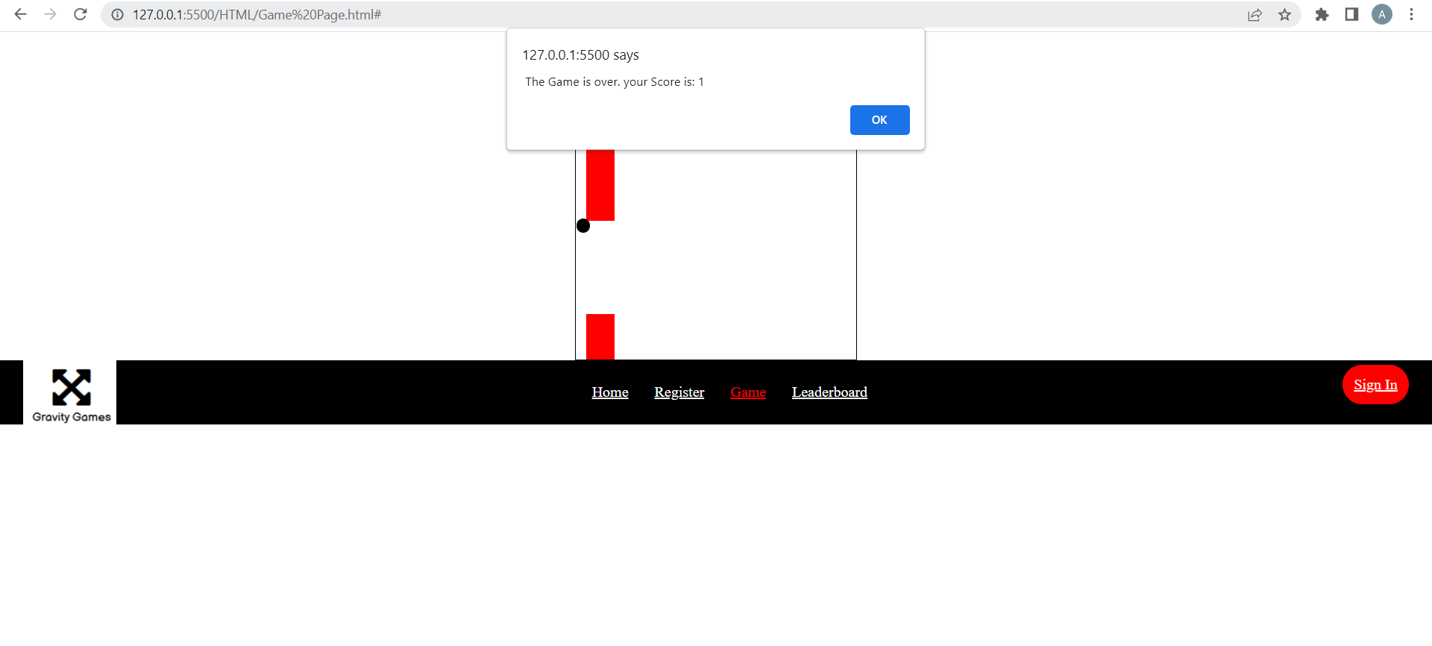This is my game, it consists of a ball going through the red pipe and until it touches it, when it does touch the game will generate a score. Pressing ok will allow you to restart the game. The aim of the game is successfully gone through the hoops with the best of your ability this game is for entertainment use only.

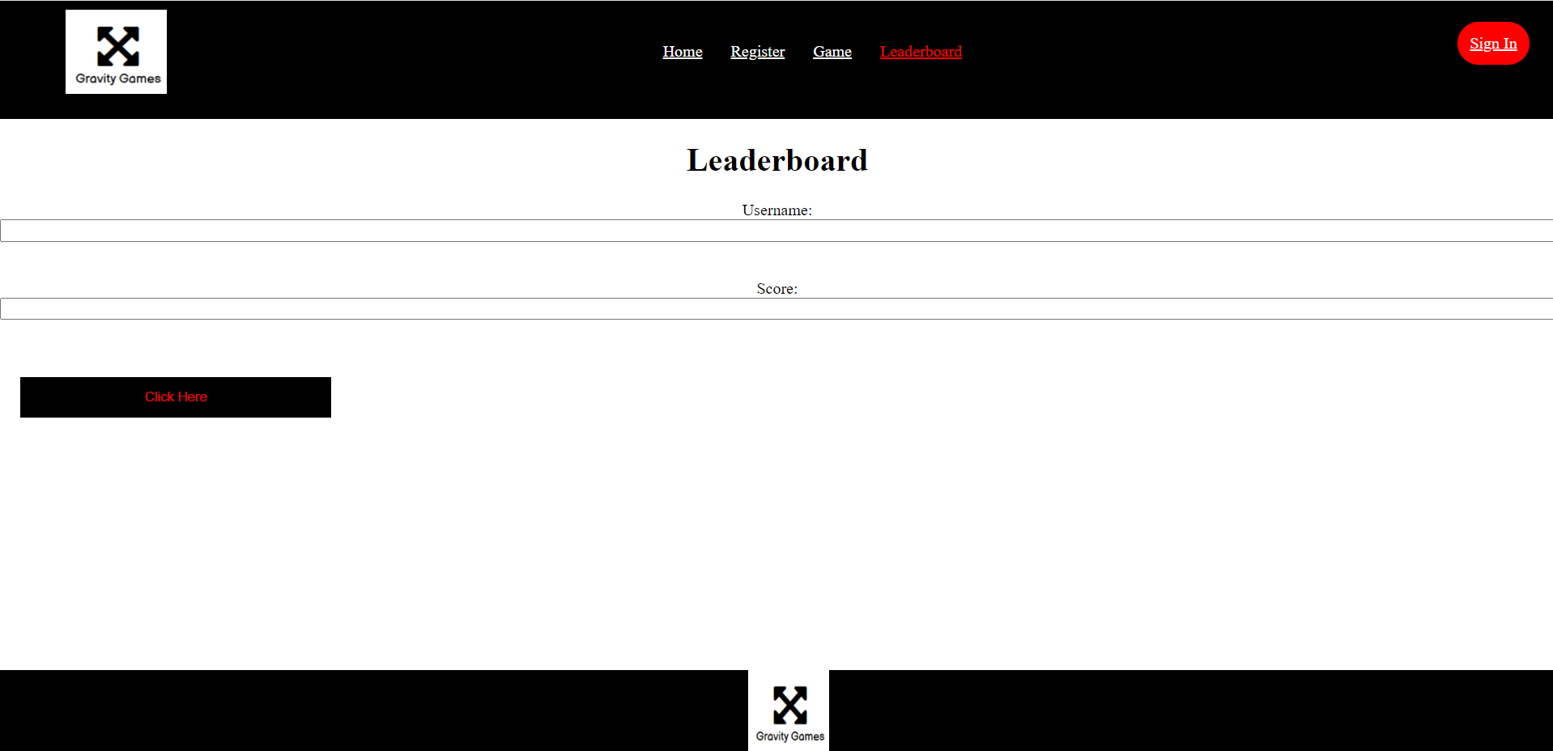

This is my leader board pageleaderboard section to which it stores the user enters their username and score and can be foundto which it is inserted in the local storage. The reason being is to enable user JSON format. This enables the user to seecheck their score stored and for them to beat it the next timein the local storage and is saved permanently.
The IssuesConclusion of Final Website
To conclude I have faced was storing the user scores and displaying the ranking page , that being saida created a functional website to which I decided to store the user score manually.
Conclusion
I have stored users details in JSON format for thea responsive registration, error handling for the login, leaderboard, and a functional game with user score.that is saved in the JSON format for all.

